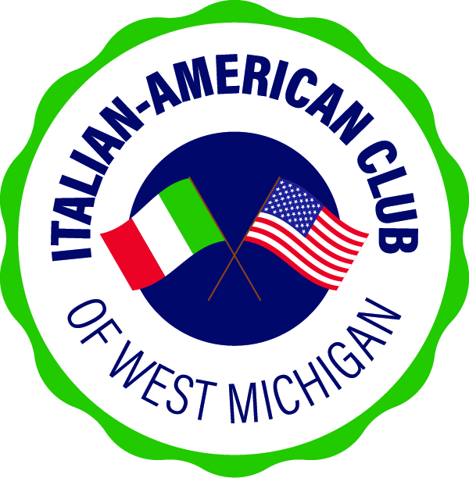

*IACWM 2025
1st Quarter
Activities & Events

JANUARY
• 30 Thursday - Meetup @ Pietro’s 6PM
FEBRUARY
• 27 Thursday - Meetup @ Alfano’s Pub and Ristorante 6PM
MARCH
• 23 Sunday - St Joseph’s Feast & Italian Wine Tasting 2PM, Bistro Bella Vita
• 27 Thursday - Meetup @ Roseanna’s Table

